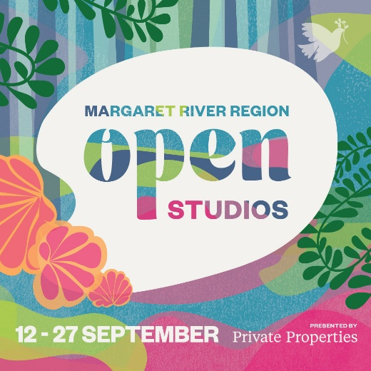
Margaret River Region Open Studios
Presented by Private Properties

Suggested Social Media Copy

Dates Saturday 12 – Sunday 27 September 2026
Suggested Copy
Discover an abundance of creativity this spring, as 155 artists of the Margaret River Region Open Studios throw open their doors and invite you to be inspired. Smell the linseed oil, see clay take shape on the wheel and timber being carefully carved.
This free event is a rare opportunity to explore private art studios; to meet painters, potters and printmakers, milliners and mosaicists, timber craftspeople, textile creators, illustrators and installation artists.
Open Studios runs 12 to 27 September 2026. Pick up a free Event Guide or follow @margaretriverregionopenstudios (IG) or /MRROpenStudios (Facebook) to find out more.
About
Margaret River Region Open Studios is an adventure in art and a rare chance to visit private studios not usually open to the public. Stretching from Eagle Bay to Hamelin Bay and Busselton to Boranup, there are 155 artists taking part this year, 30 new studios to explore and an exciting new winery venue for the Art Party and Incognito Art Auction.
Grab an Event Guide at any Jacksons Drawing Supplies store (or browse it online) to start planning your art trail adventure. The free event runs 12 to 27 September 2026.
Social Tags Website
Facebook: /MRROpenStudios www.mrropenstudios.com.au
Instagram: @margaretriverregionopenstudios #mrros
Call to action
Pick up a free Event Guide at a Jacksons Drawing Supplies or tourism venue (or browse the digital version at www.mrropenstudios.com.au/event-guide) to start planning your adventure in art.

