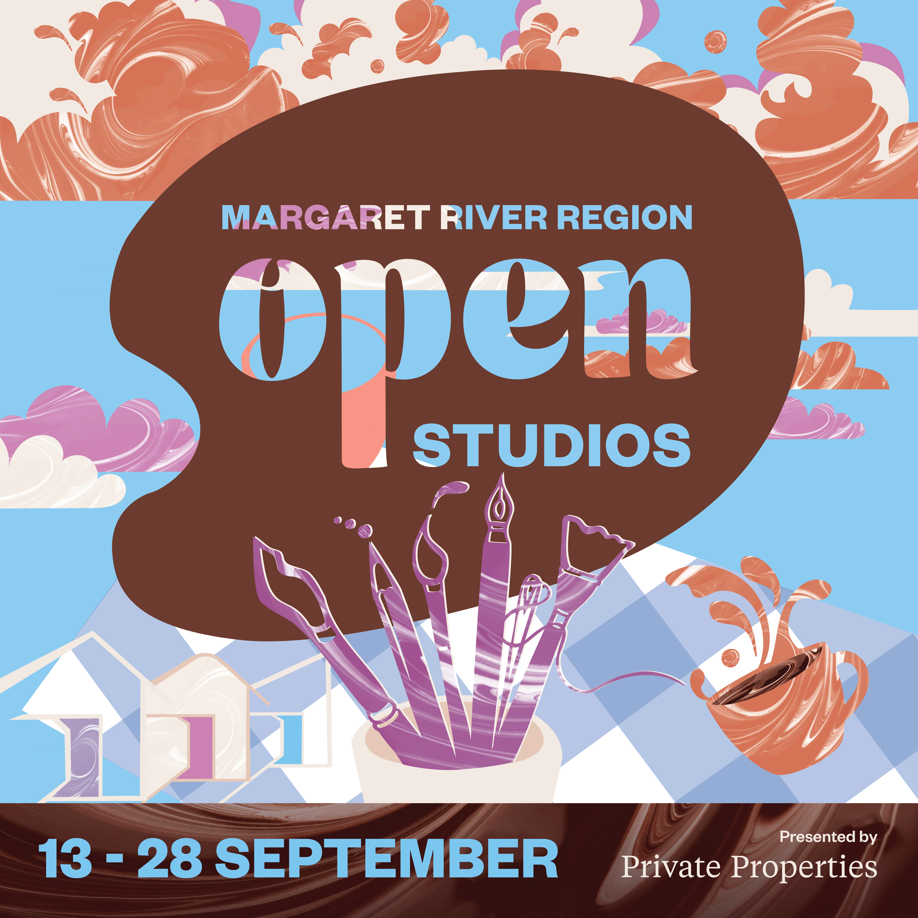

**Margaret River Region Open Studios**

**Presented by Private Properties**

**Suggested Social Media Copy**

**Dates** Saturday 13 – Sunday 28 September 2025

**Suggested Copy**

Margaret River Region Open Studios unlocks art from over 150 artists, across myriad art forms, so it’s free to be explored by art lovers everywhere.

This free event is a rare opportunity to explore private art studios; to meet painters, potters and printmakers, milliners and mosaicists, timber craftspeople, textile creators, illustrators and installation artists.

Open Studios runs 13 to 28 September 2025. Pick up a free Event Guide or follow @margaretriverregionopenstudios (IG) or /MRROpenStudios (Facebook) to find out more.

**About**

Margaret River Region Open Studios is an adventure in art and a rare chance to visit private studios not usually open to the public. Stretching from Eagle Bay to Hamelin Bay and Busselton to Boranup, there are 150 artists taking part this year, 30 new studios to explore and a new Incognito Art Auction at the Art Party.

Grab an Event Guide at any Jacksons Drawing Supplies store (or [browse it online](https://mrropenstudios.com.au/event-guide/)) to start planning your art trail adventure. The free event runs 13-28 September 2025.

**Social Tags Website**

Facebook: /MRROpenStudios [www.mrropenstudios.com.au](http://www.mrropenstudios.com.au)  
Instagram: @margaretriverregionopenstudios #mrros

**Call to action**

Pick up a free Event Guide at a Jacksons Drawing Supplies or tourism venue (or browse the digital version at [www.mrropenstudios.com.au/event-guide](https://mrropenstudios.com.au/event-guide/)) to start planning your adventure in art.