Subject Line: Art Comes Alive at Margaret River Region Open Studios
Preheader text: Plus get tickets to the first ever Art Party!
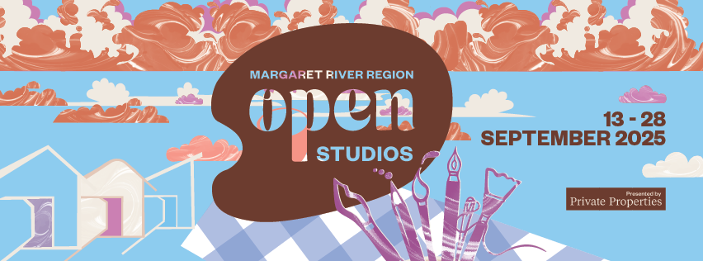
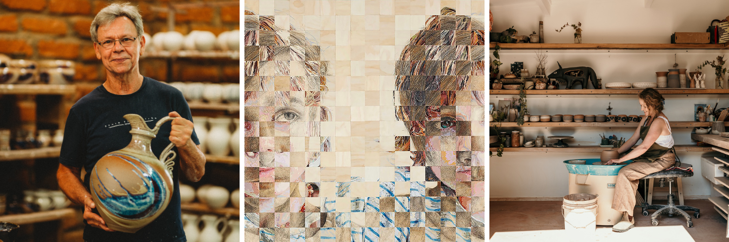
Above: Gary Hambleton, artwork by Moira Fearby and Heloise Roberts, Jolene Hewison
Art Unlocked
Margaret River Region Open Studios unlocks art from over 150 artists, across myriad art forms, so it’s free to be explored by art lovers everywhere. This free event is a rare opportunity to explore private art studios; to meet painters, potters and printmakers, milliners and mosaicists, timber craftspeople, textile creators, illustrators and installation artists.
There is a special event to celebrate 12 years, the second annual Art Party, this time held among the vines at Clairault Streicker Wines in Wilyabrup. A new Incognito Art Auction will take place, with guests enjoying the chance to bid on 20 anonymous artworks. Limited tickets are available now.
Spring is a great time to be in the region. The wildflowers are blooming, and Margaret River Region Open Studios offers a fresh, colourful and immersive experience.
Take the backroads to discover where 150 artists live and work. Pick up a free Event Guide at any Jacksons Art Supplies store. Use TrailMaker to plan and navigate your journey – choose the artists you’d like to visit and TrailMaker maps out a route.
Margaret River Region Open Studios runs for 16 days from 13 to 28 September 2025. We’re proud sponsors and hope you can take the opportunity to attend.

