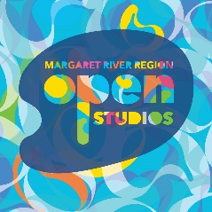
Margaret River Region Open Studios – Suggested Social Media Copy

Dates Tagline
Saturday 9th – Sunday 24th September 2022 Bumper 10th Anniversary Event

Suggested Copy
Margaret River Region Open Studios is set for a Bumper 10th anniversary event this spring. There are 166 artists, 44 new studios, 3 new exhibitions and all your favourite art forms. This free event is a rare opportunity to explore private art studios; to smell the linseed oil, see clay take shape on the wheel, timber being carefully carved, and metal being melded.
There are special events to celebrate the 10-year milestone, including Breakfast with Art Ambassador and multi-award winning Australian artist Michael Zavros and a special Anniversary Art Dinner in the sumptuous surroundings of Aravina Estate.
The free event runs 9 to 24 September 2024. Pick up a free Event Guide or follow @margaretriverregionopenstudios (IG) or /MRROpenStudios (Facebook) to find out more.

About
Margaret River Region Open Studios is an adventure in art and a rare chance to visit private studios not usually open to the public. Stretching from Eagle Bay to Hamelin Bay and Busselton to Boranup, there are 166 artists taking part in the bumper 10th anniversary event, and 44 new studios to explore.
Grab an Event Guide at any Jacksons Drawing Supplies store (or browse it online) to start planning your adventure in art. The free event runs 9 to 24 September 2022.

Social Tags Website
Facebook: /MRROpenStudios www.mrropenstudios.com.au
Instagram: @margaretriverregionopenstudios #mrros
Call to action
Pick up a free Event Guide at a Jacksons Drawing Supplies (or browse the digital version at www.mrropenstudios.com.au/event-guide) to start planning your adventure in art.

