Here is suggested text and images for a newsletter. If you’d like any further suggestions, please contact Lizzy Pepper on 0409 084 737 marketing@mrros.com.au

Subject Line: Bumper 10th Anniversary Event for Margaret River Region Open Studios
Preheader text: Plus 3 new exhibitions and events
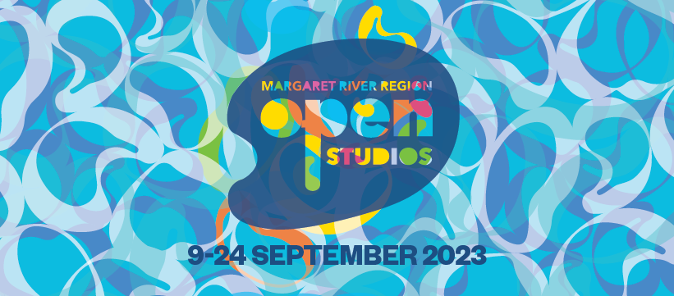
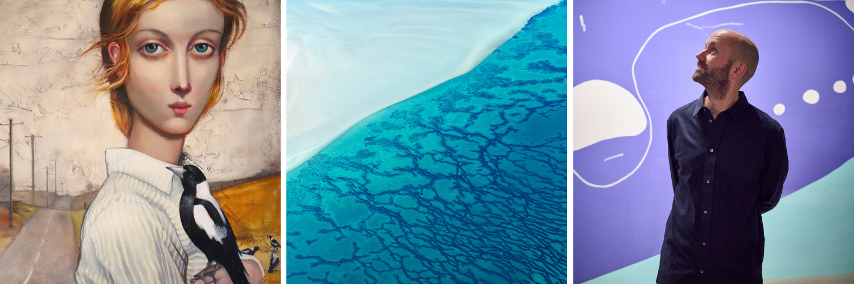
Above: artworks by Lauren Wilhelm, Anton Felix Blume and Ian Daniell

Bumper 10th Anniversary Event
Margaret River Region Open Studios is set for its biggest and best event in its 10-year history. There are 166 artists, 44 new studios, 3 new exhibitions and all your favourite art forms. This free event is a rare opportunity to explore private art studios; to smell the linseed oil, see clay take shape on the wheel, timber being carefully carved, and metal being melded.
There are special events to celebrate the 10-year milestone, including Breakfast with Art Ambassador and multi-award winning Australian artist Michael Zavros and a special Anniversary Art Dinner in the sumptuous surroundings of Aravina Estate.
Spring is a joyous time to be in the region. The wildflowers are blooming, and Margaret River Region Open Studios offers a fresh, colourful and immersive experience.
Take the backroads to discover where 166 artists live and work. Pick up a free Event Guide at any Jacksons Art Supplies store. Use the new TrailMaker to plan and navigate your journey – choose the artists you’d like to visit and the TrailMaker maps out a route.
Margaret River Region Open Studios runs for 16 days from 9 to 24 September 2023. We’re proud sponsors and hope you can take the opportunity to attend.

