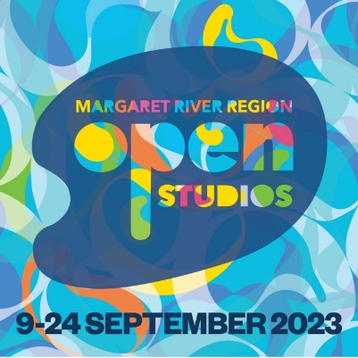

**MEDIA RELEASE 22 June 2023**

**A 10-year anniversary, over 160 artists and two Art Ambassadors – this year’s Open Studios will be a corker!**

Australia’s largest Open Studios event has officially launched with a number of exciting new initiatives to mark its 10th year. A huge 166 artists have signed up for September’s Margaret River Region Open Studios and almost a third will be participating for the first time!

The Margaret River Region has again proven itself to be a rich and diverse source of artistic talent. Regular Open Studios devotees will be able to discover new studios as well as returning to see new work in progress from their favourite artists.

For the first time, Margaret River Region Open Studios will host two Art Ambassadors; renowned Queensland painter and sculptor Michael Zavros and Perth-based designer and champion of art and design Andrew Thornton Hick.Zavros will make his first trip to Western Australia and attend the first week of the 16-day event.

Zavros is a thought provoking, award winning Australian artist. He works across a multitude of mediums Including painting, drawing, sculpture, photography and film. He work is held in the collections of most major Australian galleries and his 25 year exhibition opens at Queensland Art Gallery of Modern Art this month.

As well as visiting artists in their studios, he will speak at an Artist Talk with Q & A Breakfast, hold a masterclass for Open Studios artists and attend the events major fundraiser, Art Dinner at Aravina Estate. As part of this, he has also offered an amazing tour of his studio in Queensland as a money can't buy auction item.

“I’m looking forward to being part of Margaret River Region Open Studios. This will be my first visit to WA and I’ve heard great things about the Margaret River region including the vibrant creative scene. I’ll be putting down my brushes and meeting some of the local artists in their studios, which is what the event is all about.”

Andrew Thornton Hick has been an avid supporter of Open Studios for many years, and this year comes on board to help document and promote the artists and activate new markets within Western Australia's architecture and design space.

Deputy Chair Jacquie Happ said this year would be a celebration in more ways than one.

“For an event of this kind, managed by a volunteer committee, 10 years is a milestone achievement. There are thirteen artists who have been participating in the event each year since it started, and there are many who return each year. There has been substantial growth in the quality of artworks as it is a unique opportunity to reach a broad audience.

“And these are of course not all necessarily artists who have recently taken up art, but rather artists who have chosen to call the Margaret River region home in recent years. And why wouldn’t they? We are surrounded by natural inspiration.

“This year we have artists opening their studios from Busselton to Augusta and in an exciting array of artforms …. drawing, glass, jewellery, mixed media, mosaics, painting, photography, pottery, ceramics, printmaking, sculpture, textiles, upcycling, and woodwork.

“We have launched a new website this year which will allow visitors to take a deeper dive into our creative talent pool and make it easier for them to plan their artistic adventure.”

The website is now live with profiles of each participating artist and includes a new Artist TrailMaker feature where visitors can map a trail of their favourite artists, artforms or locations. This year’s participating artists include Leon Pericles, Lauren Wilhelm, Rebecca Cool, Lesley Meaney, Ian Daniell, John Miller, Mary-Lynne Stratton, Rachel Coad, and Christian Fletcher.

Artists across the glorious Margaret River Region throw open their studio doors from 9 to 24 September and invite in art-inquisitive visitors to have a peek into their creative worlds.

Hobbyist, emerging and professional artists will share their usually-private worlds. Kilns will be firing, lathes turning, oil paints daubed on palettes, printing presses cranking, fabrics stretched, precious metals tempered, glass blown, and mosaics cut.

Margaret River Region Open Studios won gold at the 2022 WA Tourism Awards for Festivals and Events.

Pick up an event guide closer to the event from your nearest Jackson’s Drawing Supplies, or view online, regional visitor centres and visit [www.mrropenstudios.com.au](http://www.mrropenstudios.com.au) for more information and inspiration.

Studios typically open from 10am to 4pm daily, but please check the website or event guide for details. Book your accommodation now to avoid disappointment - visit margariver.com and event partner PrivateProperties.com.au for inspiration.

Margaret River Region Open Studios is made possible thanks to Tourism Western Australia, Government of Western Australia, Jacksons Drawing Supplies, Rio Tinto, Private Properties, Swings & Roundabouts, The West Australian, City of Busselton and the Shire of Augusta Margaret River with support from Art Partner Art Gallery of Western Australia.

**Website**: www.mrropenstudios.com.au

**Facebook**: @mrropenstudios

**Instagram**: @margaretriverregionopenstudios

**Video:** https://vimeo.com/mrros

**Image downloads:** https://www.dropbox.com/sh/awc1z8enpy8iznl/AACeasJ2xbkHrho335UIgBkDa?dl=0

-ENDS-

**Media contact:**  Janine Pittaway 0418911796 jpittaway@brightcommunications.com.au